Department of Computer Science and Information Technology
CT-159 Data Structure Algorithms and Applications
Assignment # 01
Date: 16-10-2025 Marks: 10
Instructions:
Submit assignment in hard copy with handwritten
The deadline is 22nd October 2025
Copying content from another student's assignment, whether fully or partially, is considered academic dishonesty and result in Deduction of marks (up to full marks for that question or the entire assignment).

Question-1____________________________________________________________________
- List at least five real-world applications of data structures. Specify which data structure is used and why it is suitable for that use case.
- Discuss how data structures impact the efficiency and scalability of software systems.
- Explain the differences between linear and binary search in terms of:
- Algorithm
- Time complexity
- Applicability

(d) Given the array:
A = [3, 7, 12, 19, 24, 31, 42]

Write the steps(program) of binary search to find the element 24.
How many comparisons are made?

(e)For each of the following code snippets, determine the time complexity in Big O notation.
Problem-1

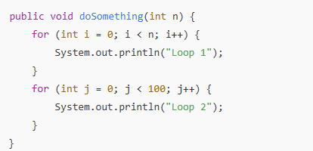
Problem-2
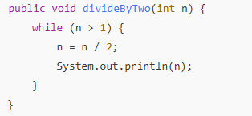

Problem-3
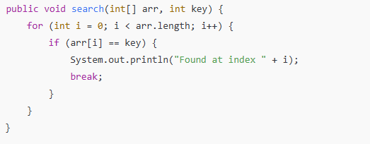
Problem-4

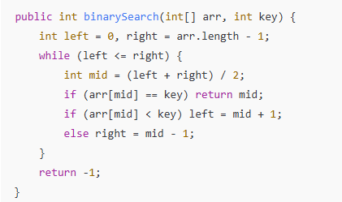

Question-2___________________________________________________________________
- For each scenario below, suggest the most suitable data structure and algorithm to use, and explain your reasoning:
- Storing and quickly retrieving a large set of unique user IDs
- Managing browser back/forward functionality
- Implementing undo/redo in a text editor
- Continuously inserting and removing tasks based on priority

- Write two separate functions(program) for:
- Linear search
- Binary search
Each should return the index of the target if found, otherwise -1. Include input validation to ensure binary search is only performed on a sorted array.
Question-3 __________________________________________________________________________
You are developing a music player application that allows users to manage a playlist of songs. Each song contains the following information:
- Song title (string)
- Artist (string)
- Duration (in seconds)
The playlist should allow the user to:
- Add a new song at the end of the playlist.
- Delete a song by its title.
- Display the current playlist in order.
- Search for a song by its title.
- Play the next song, simulating moving to the next song in the list.
Because the number of songs can vary dynamically and insertion/deletion happens frequently, you decide to use a singly linked list to represent the playlist.
Question-4 __________________________________________________________________
Define pseudocode.
- What are the main benefits of writing pseudocode before coding a data structure operation?

- What is the purpose of an algorithm in solving problems using data structures?
- Provide examples where algorithm choice impacts the efficiency of a data structure.

- Explain how pseudocode helps in bridging the gap between problem-solving and implementation.
- Support your answer with an example involving a common data structure (e.g., stack or queue).
- You are asked to implement a queue using a linked list.
Write the pseudocode for the enqueue and dequeue operations and explain how it helps during implementation.

